**Boise School District (BSD) Technology Accounts Information**

**Welcome to the Boise School District!** Your email address is the account you will use for logging in to most systems at the Boise School District. It will be as follows: [*firstname.lastname*@boiseschools.org](mailto:firstname.lastname@boiseschools.org). Your initial password is supplied by the HR department.

Use this to log in on any Windows computer, Chromebook or Macbook. This will also be your login to your BSD Gmail and other Google Workspace apps, like Drive, Calendar, and Classroom.

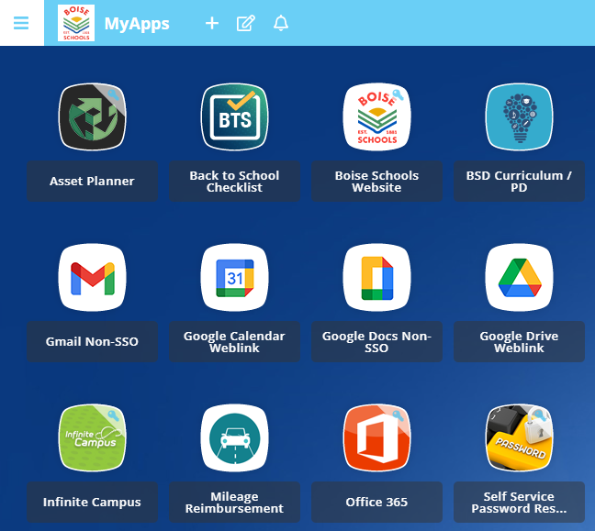

**MyApps**: This is the launchpad for all apps you need to use and is found at [myapps.boiseschools.org](https://myapps.boiseschools.org). A shortcut is also on your Windows desktop. Once logged into Windows and Google, the district uses Single Sign-on (SSO) to authenticate you to many applications found in MyApps without the need to enter your credentials again. BSD recommends using Chrome browser and signing in to the browser for the best single sign-on and app experience.

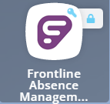

**Frontline Absence Management/Time & Attendance**: This is where you will report absences, request a substitute (if applicable), view timesheets, and find leave balances. You can find the shortcut in the MyApps portal, in the folder named Human Resources. Classified staff will use Time & Attendance to clock in and out.

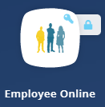

**Employee Online:** This is the system for you to access and update your emergency contacts, address, tax information, check stubs, and other payroll information.The initial username and password will be sent to your physical address from the Payroll Department, and is not your email address. The password must be changed every 365 days. The ‘Forgot Login’ feature allows you to reset your password.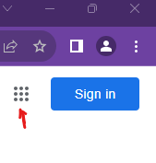

**Google Workspace for Education**: BSD uses Google’s Suite of apps, such as Gmail, Calendar, Drive, Sheets, and Classroom. Links are in MyApps or go to google.com, click the blue Sign in button. Click the “grid” to explore more apps!

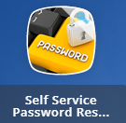

**Self-Service Password Reset**: This is where you will register for and set up identity verification methods for resetting your BSD account password if needed. The shortcut is in the MyApps portal and can also be found at [myaccount.boiseschools.org](https://myaccount.boiseschools.org)

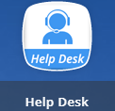

**Support**: Access our support website, found at [support.boiseschools.org](https://support.boiseschools.org) for chat support and help articles for many technology questions. Support is also available by email: support@boiseschools.org, or phone: (208)854-6670.